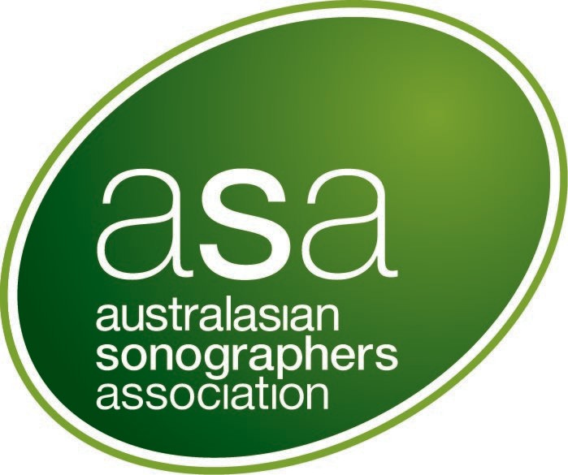

ASA research grant

Application Form | 2026 Funding round

Level 2, 93–95 Queen Street, Melbourne 3000, VIC, Australia | T +61 3 9552 0000  F +61 3 9558 1399 | sonographers.org  August 2026

table of contents

Background 3
Grant assessment 3
Conditions of the grant 4
Payment of the grant 4
Application Form 5
Declaration 13
Checklist for ASA Research Grant Applicants 14

Background

The ASA Research Grant offers funding of up to AU$30,000 to support one or more original research projects that advance sonographic practice. The grant aims to facilitate high-quality research by ASA members, leading to peer-reviewed publications and contributing to the evidence base in sonography.

Eligible applicants are ASA members with the Accredited Medical Sonographer membership type (Australia/New Zealand). Applications must be submitted via email to researchandstandards@sonographers.org by 5 pm (AEST) on 30th September 2026.

Applicants will be advised of the outcome of their application by 29 January 2027.

Grant assessment

Applications will be reviewed by a panel comprising three ASA Accredited Medical Sonographer (AUS/NZ) members with relevant research experience and an ASA Office representative. The panel may co-opt an additional member if experience in a particular field is required.
The following criteria will be used to assess applications for grant funding.

- The proposed outcomes/findings of the project will significantly contribute to the evidence- base of sonography.

- Relevance to sonographic practice.

- Feasibility, including design, budget, and timeline (with completion expected in the calendar year following the grant being awarded).

- The principal researcher is an ASA Accredited Medical Sonographer (AUS/NZ) member with research experience or can show evidence of being supervised or mentored by an experienced researcher.

- The principal researcher is not a principal investigator of a previously awarded ASA Research Grant.

- A clear and justified budget including eligible costs for:
  - consumables and equipment
  - salaries/personnel (paid at gazetted research assistant or sonographer rates)
  - travel related to data collection
  - expenses for conference attendance to present findings (up to AU$1,000.00 for travel and/or conference fees
  - publication costs (reputable peer reviewed journal).

Funding will not be provided for items already covered by other grants. The panel reserves the right not to award funding if applications do not meet the required standard.

Funds for the successful applicant(s) are not released prior to 1) ASA board approval, 2) execution of an agreement between the ASA and the host organization or individual applicant and 3) all precedent conditions as outlined in the agreement are met.

Conditions of the grant
- The recipient will present a subject review and their rationale and findings at an ASA webinar (Note: This will not exclude participants from presenting their findings at other scientific meetings). Recipients are also encouraged to submit abstract(s) of their research for presentation at the ASA Annual International Conference.

- Recipients that receive funding of 50% or more of the grant pool are required to submit at least one manuscript to the ASA journal Sonography for peer review and potential publication within two years of receiving the funding.
Recipients who receive less than 50% of the grant pool are required to provide evidence within two years of receiving the funding that they have submitted a draft manuscript on their research to a peer reviewed journal. They are encouraged to consider submitting a manuscript to the ASA journal Sonography.

- The recipient will provide an interim progress report within six months after commencing the project.

- At the conclusion of the grant, the recipient will provide a grant report that includes statements on the progress and outcomes of the research, including successes and challenges, and budget adherence.
- All presentations or publications must acknowledge the support of the ASA as a grant funding body.

Payment of the grant
Funding may be accepted in one of two ways, each with distinct GST implications:
- Via an institution or organisation: The host must issue a tax invoice to ASA for the grant amount plus GST.
- Directly to the individual: The applicant must provide an invoice with ABN and bank details. Applicants are advised to seek financial advice regarding potential tax implications.

Application Form

SECTION A – OVERVIEW
Principal investigator (applicant):
Title and salutation:
ASA Member number:
Host organisation:
Please include a contact name and contact details
Project title:
Project summary (max. 300 words):
Provide a lay summary of the project. Outline how the project will add to the sonography evidence base and/or
improved patient outcomes

List sites at which the project will be conducted:
Total amount requested $AUD (including GST if applicable):  Total not to exceed AU$30,000  To be detailed at Section D – Budget |  |  | $
Project duration:
Up to 12 months
Submissions to other funding sources for this project:
Include planned, submitted or approved applications. List the funder, expected date of notification of success and the amount(s) requested/granted
Has the principal investigator been the recipient of monetary awards/grants issued by the ASA in the past?
If so, please provide details including the year of grant/award
If your application is successful, will the funding be held by an educational institution or other organisation on your behalf?
Yes ☐ No ☐
If yes, please indicate the name and address of the institution or organisation
OR
If your application is successful, will the funding be paid to you as an individual?
Yes ☐ No ☐
Note: there may be tax implications for you with this option, and you are encouraged to have obtained financial advice on this.
Indicate the permissions and/or approvals required to undertake your research project.
(where relevant, provide current progress, and expected approval dates)
Does the funding support a project being undertaken by the applicant to meet requirements for a higher degree?
If so, indicate the type of degree, i.e., Masters’ degree or PhD. How much does the project contribute towards the degree?

SECTION B – RESEARCH TEAM
B1 Principal Investigator (Applicant) Details
Please attach your CV including qualifications, grants previously received, and relevant publications which both
support your application and inform understanding of the project. Please limit your CV to 3 pages.
Full name:
Please include title/salutation
Position:
Organisation:
Contact phone number:
Email:
Postal address:
Principal researcher’s contribution to research
(Describe the roles that will be undertaken by the principal researcher)
B2 Associate Investigators (Up to 5)
At least one mentor must be identified if the applicant does not have a proven research track record.
Attach a limited CV (maximum 3 pages) of all investigators including qualifications, selected grants
previously received and publications which support the application and inform understanding of the
project.
The grant panel uses this information to assess if investigators have appropriate skills and training to undertake the research
Full name and title: |  | Contact details  (email and phone) |  | Position: | Organisation: | Contribution:
1.
2.
3.
4.
5.

SECTION C – RESEARCH PROPOSAL
State the aim(s) or objective(s) of the research project.
State the research question(s) and hypothesis if applicable.
(max 150 words)
Describe the problem, any related background information, prior research, gaps in the literature (max. 300 words).
Justify why the research should be undertaken, how it will advance knowledge or understanding, and what benefits the outcomes will have. i.e., what new or relevant evidence will the research project generate for sonographic practice/policy or patient outcomes? (max. 200 words)
Describe the research (max. 800 words)
Include details such as study design (and why it is appropriate to answer the research question), sampling methods, selection criteria, primary and secondary outcomes, data sources/research tools, data collection methods, sample size and power calculations, statistical analysis and resources required.
Describe any potential barriers and risk mitigation strategies (max 200 words). Include any potential delays for outstanding key approvals that are needed for the project.
Describe consideration given to scalability and value for money of your research project and outcome (max. 150 words). Scalability refers to how the project or its outcomes can be adapted on a wider scale or used within different contexts.
What are your plans for promoting research outcomes? (max. 200 words)
Please provide a timeline of tasks required to complete the project in 12 months. Examples of tasks include ethics approval, participant recruitment, data collection, data analysis, reporting.
Reference list

SECTION D – BUDGET
- Provide here detail of requested funds
For salaries, please specify the salary level, on-costs and FTE allocation.
Applicants are reminded to include GST costs where relevant.
Please note the budget must be expended within one year of provision.
Budget item:  e.g. Salary (research assistant) | Funding requested ($AUD): | Description and justification for budget item:  (< 100 words per item). Please indicate all cash and in-kind contributions
TOTAL | $ 0.00
- Provide details of other contributions related to the project that are not included in this application. Include co-contributions (monetary or in-kind) scholarships, and other grant funds which are available for the project.
Budget item: | Description of budget item:  (< 100 words per item).
- Have any of the budget items outlined in D1 been included in an outstanding grant application submitted to another institution?
Applicants should notify the ASA as soon as possible of any successful grant applications which include any of the budget items requested in this grant under D1.

- Could you complete the research or part of the research, resulting in a publication if full funding is not available? Provide an explanation (150 words max).

Declaration

Please attach a letter from the host organisation verifying that:

  - they have read and understood the implications of this project to the organisation
  - they support the project.

Save your form and attachments as a word file using the following naming convention:

Your surname ASA application.docx
e.g. Smith ASA application.docx

Email the form to researchandstandards@sonographers.org

Signature of Applicant (Principal Investigator):

Name:
Signature:
Date:

Checklist for ASA Research Grant Applicants

Task
- The principal investigator in an ASA Accredited Medical Sonographer member | ☐
2. All sections of the Application form are complete | ☐
3. You have complied with the document instructions, including any indicated word limits | ☐
4. CVs for all people listed in Section B are included | ☐
5. A letter from the host organisation is included | ☐
6. The Application is signed and dated | ☐
7. The Application and attachments are saved as a PDF file using the naming  convention | ☐
8. The Application and attachments are submitted electronically before the  deadline | ☐

