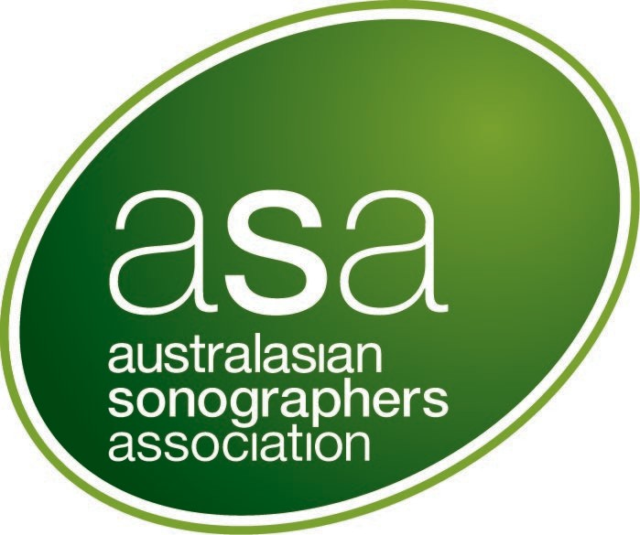

ASA clinical audit grant

Application Form | 2026 Funding round

Level 2, 93–95 Queen Street, Melbourne 3000, VIC, Australia | T +61 3 9552 0000  F +61 3 9558 1399 | sonographers.org  August 2026

table of contents

Background 3
Grant assessment 3
Conditions of the grant 4
Payment of the grant 4
Application Form 5
Declaration 9
Checklist for ASA Clinical Audit Grant Applicants 10

Background

The ASA, with support from Marsh Advantage Insurance Pty Ltd, is offering two clinical audits grants of up to AU$5000 each, to be undertaken and completed in 2027.
These grants support ASA members to conduct clinical audits that:

- Improve patient outcomes.
- Addresses an area(s) of high need.
- Enhance the safety, quality, efficiency and effectiveness of sonography services.
Applications are invited from ASA members with the Accredited Medical Sonographer AUS/NZ membership type. To apply, complete the application form and submit it, along with all required attachments, via email to researchandstandards@sonographers.org by 5 pm (AEST) 30th September 2026.

Applicants will be advised of the outcome of their application by 29th January 2027.

Explanation of clinical audit

Clinical Audit improves standards of clinical practice and the quality of patient care by measuring healthcare effectiveness against agreed or proven standards of care. It allows for education, training, and re-audit to confirm improvements.
There are important differences between clinical audit and research. Clinical audit evaluates current clinical practices against exiting standards to improve services. Unlike research, which generates new knowledge and is designed to be replicable, audit results may not be transferable to other settings.
Clinical audits must follow an ethical framework to protect patient and staff confidentiality, privacy and safety. Ethical approval is usually required for any investigations which involve people, their data or their tissue. There can be exemptions, but this should be confirmed by a Human Research Ethics Committee.

Grant assessment

A review panel composed of three ASA Accredited Medical Sonographer (AUS/NZ) members with clinical audit experience and an ASA Office representative will assess the applications. The review panel may co-opt an additional member if experience in a particular field is required.
Applications will be assessed based on the criteria outlined below. If applications are not of a high enough standard to offer a grant(s), the panel reserves the right not to offer a grant(s). Funds for the successful applicant(s) are not released prior to 1) ASA board approval, 2) execution of an agreement between the ASA and the host organization or individual applicant and 3) all precedent conditions as outlined in the agreement are met.

 | Weighting | Description
Mandatory criteria | Application not eligible if mandatory criteria not met. | - Principal investigator is an ASA Accredited Medical Sonographer (AUS/NZ) member with clinical audit experience or has a mentor who does.  - The principal investigator is not the principal investigator of a previously awarded ASA Clinical Audit Grant.  - The proposed clinical audit has agreement from the host organisation to support the project and meet any costs of the project not covered by grant funding.  - Requested items for funding in this application are not funded or pending funding from other grants.  - Ethics approvals or exemptions are clearly stated, including the relevant committees or organisations.  - The project must be distinguishable from a research project. It should be an evaluation of whether clinical practice or service provision meets standards and aims to improve services rather than to generate new knowledge.
Project impact | 20% | - Describes how the project improves patient outcomes, addresses high need areas, or enhances sonography service quality, efficiency, safety or effectiveness.  - If the project is applicable to settings outside of the setting where the audit was performed. It is accepted that audit findings may not be transferable to other settings.
Project methodology | 40% | - Project design is appropriate to meet projective aims and/or objectives within 12 months.
Capacity, capability and resources to deliver the project | 40% | - Budget supports successful completion of project.  - Qualifications and skilled personnel to undertake project.  - Availability of equipment to undertake the project.  - Access to relevant data to meet project objectives.  - Project completion is feasible within 12 months.
Overall Value and Risk of the Project | Non-weighted | - The suitability of the proposed budget to complete all project activities.  - How well the requested budget has been detailed and justified.  - Risks are identified and mitigation strategies proposed.

Conditions of the grant
- The recipient will agree to undertake at least one of the following; 1) a subject review (includes rationale and findings) recorded as an ASA webinar, 2) submit an abstract for an oral presentation/poster presentation at the ASA Annual International Conference, 3) submit a manuscript to the ASA journal Sonography.

- The recipient will provide an interim progress report within six months after commencing the project.
- At project completion, the recipient must submit a report that includes statements on the audit methodology, findings (and their significance), and budget adherence.
- All outputs arising from this project must acknowledge Marsh Advantage Insurance Pty Ltd and ASA as funding supporters.

Payment of the grant
Funding may be accepted in one of two ways, each with distinct GST implications:
- Via an institution or organisation: The host must issue a tax invoice to ASA for the grant amount plus GST.
- Directly to the individual: The applicant must provide an invoice with ABN and bank details. Applicants are advised to seek financial advice regarding potential tax implications.

Application Form

SECTION A – OVERVIEW

Principal investigator (applicant):

Title and salutation:

ASA member number:
Host organisation:
Please include a contact name and contact details.

Project title:
Project summary (max. 300 words):
Provide a lay summary of the project. Outline the project impact; how it will improve patient outcomes/address an area of high need/improve the safety, quality, efficiency or effectiveness of sonography services.

List site(s) at which the project will be conducted:
Total amount requested $AUD (including GST if applicable): Total not to exceed AU$5000

To be detailed at Section D – Budget
Project duration:

Up to 12 months
Submissions to other funding sources for this project: Include planned, submitted or approved applications.

List the funder, expected date of notification of success and the amount(s) requested/granted.
Has the principal investigator been the recipient of monetary awards/grants issued by the ASA in the past?

If so, please provide details including the year of grant/award.
If your application is successful, will the funding be held by an institution or other organisation on your behalf?
Yes ☐ No ☐
If yes, please indicate the name and address of the institution or organisation.

OR
If your application is successful, will the funding be paid to you as an individual?
Yes ☐ No ☐

Note: there may be tax implications for you with this option, and you are encouraged to have obtained financial advice on this.
Indicate the permissions and/or approvals required to undertake your project (include the organisations from which approvals are required).
(where relevant, provide current progress, and expected approval dates)
Please note: Clinical Audits may be exempt from assessment by an ethical committee. It is advised that ethical assessment requirements and processes are checked prior to submitting your application. Evidence of either ethics approval or ethics exemption must be provided before funding will be released to successful applicant(s).
Does the funding support a project being undertaken by the applicant to meet requirements for a higher degree?
If so, indicate the type of degree, i.e., Masters’ degree or PhD. How much does the project contribute towards the degree?

SECTION B – PROJECT METHODOLOGY
State the aim(s) or objective(s) of the clinical audit project. They should be specific, measurable and achievable.

(max 150 words)

Describe the problem that the clinical audit addresses and who will benefit? (max. 200 words)

How will patient and staff privacy and confidentiality be protected? (max. 200 words)

Description of the clinical audit (maximum of 100 words for each sub-section)

What resources are required for the audit?

(include the staff/time/resources needed for consultations or meetings, data collection, analysis and reporting).

Where will the clinical audit be performed? Include name of organisation and/or clinical site(s).

What items or variables will be audited?

Define the audit standards and their source.

(the audit standards may be expressed as a percentage of a target, the audit standards may be derived from published literature, international, national or local guidelines, or by agreement from interested parties or local auditing teams)

Who are the key stakeholders in your project, and how will they be involved in the project? For example, key stakeholders may form an advisory group for the project. (max. 150 words)

Describe your data source (i.e., manual or computer records), and if data collection will be retrospective or prospective.

Provide an estimation of how long the data collection will take.

State your planned sample size (i.e., number of patients or examinations) and provide a justification for it. Sample sizes will depend on what is being evaluated, the amount of information being collected, the ease of data collection, resources available and/or size of target population.

How will data be analysed? i.e. how will you compare actual performance to the set standard; how will you determine if the set standard has been met?

How, and to whom will results be disseminated?

How will the results of the audit be used to make improvements and/or implement change?

Describe any potential barriers and risk mitigation strategies (max 200 words). Include any potential delays for outstanding key approvals that are needed for the project.

Describe consideration given to scalability and value for money of your project and outcome (max. 150 words). Scalability refers to how the project or its outcomes can be adapted on a wider scale or used within different contexts.

List any relevant references.

SECTION C – Capacity, capability and resources to deliver the project

C1 Principal Investigator: Please attach your CV including qualifications, grants previously received, and relevant publications which both support your application and inform understanding of the project. Please limit your CV to 3 pages.
Full name:
Please include title/salutation

Position:

Organisation:

Contact phone number:

Email:

Postal address:
Principal investigator’s contribution to the project. (Describe the roles that will be undertaken by the principal investigator)
C2 Associate Investigators (Up to 5)
At least one mentor must be identified if the applicant does not have experience in clinical audits.
Attach a limited CV (maximum 3 pages) of all investigators including qualifications, selected grants previously received and
publications which support the application and inform understanding of the project.

The grant panel uses this information to assess whether investigators have appropriate skills and training to undertake the clinical audit.
Full name and title: |  |  |  | Contact details  (email and phone) |  |  | Position: | Organisation: | Contribution:

a)

b)

c)

d)

e)
C3 Budget: Provide detail of requested funds here. Expenditure must be a direct cost of the project and be incurred for required project audit activities.
For salaries, please specify the salary level, on-costs and FTE allocation.
Applicants are reminded to include GST costs where relevant.

Please note the budget must be expended within one year of provision
 | Budget item:  e.g. Salary (research assistant) |  | Requested amount ($AUD): |  |  | Item description and justification:  (< 100 words per item). Include all cash and in-kind contributions.
 | TOTAL |  | $ 0.00
Details of other contributions related to the project that are not included in this application. Include co-contributions (monetary or in-kind) and other grant funds which are available for equipment and salaries.
Budget item: | Description of budget item:  (< 100 words per item).
Have any of the budget items outlined in C3 been included in an outstanding grant application submitted to another institution? Yes/No

Applicants should notify the ASA as soon as possible of any successful grant applications which include any of the budget items requested in this grant under C3.

Declaration

Please attach a letter from the host organisation verifying that:
  - they have read and understood the implications of this project to the organisation and they support the project and agree to meet the costs of the project not covered by the grant funding.

Save your form and attachments as a word file using the following naming convention:

Your surname ASA clinical audit.docx
e.g. Smith ASA clinical audit.docx

Email the form to researchandstandards@sonographers.org

Signature of Applicant (Principal Investigator):

Name:
Signature:
Date:

Checklist for ASA Research Grant Applicants

Task
- The principal investigator in an ASA Accredited Medical Sonographer member | ☐
2. All sections of the Application form are complete | ☐
3. You have complied with the document instructions, including any indicated word limits | ☐
4. CVs for all people listed in Section B are included | ☐
5. A letter from the host organisation is included | ☐
6. The Application is signed and dated | ☐
7. The Application and attachments are saved as a PDF file using the naming  convention | ☐
8. The Application and attachments are submitted electronically before the  deadline | ☐

